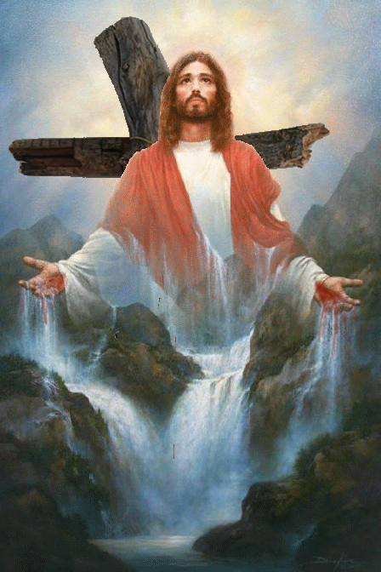
Calvary’s Song

Merciful Father,
You have led me to the cross and I sing!
Here I fling down all my burdens and see them vanish.
Here mountains of guilt are leveled to a plain.
Here my sins disappear,
though they are the greatest that exist
and are more in number than the grains of fine sand.

For there is power in the blood of Your Son
to destroy sins more than can be counted.
You have given me a hillside spring
that washes clear and white,
and I go as a sinner to its waters,
bathing without hindrance in its crystal streams.

The blood of the Lamb is like a great river of infinite grace
with never any diminishing of its fullness or purity
as thirsty ones drink from it
and dirty ones cleanse.

O Lord, forever will Your free forgiveness live
that was gained on the mount of blood;
In the midst of a world of pain
it is a subject for praise in every place,
a song on earth,
an anthem in heaven,
a hymn to be sung for eternity,
a chorus to be repeated throughout all creation.

I have a longing for the world to come
where multitudes sing this great melody,
for my soul was never created to love a world apart from You.
Though here my spiritual state is weak and poor,
there I shall go on singing Calvary’s anthem with never ending strength.

May I always know
that only a clean heart can sing by night and by day,
and that such a heart is mine when I abide in my Savior’s cross.

− The Valley of Vision, p. 171.

